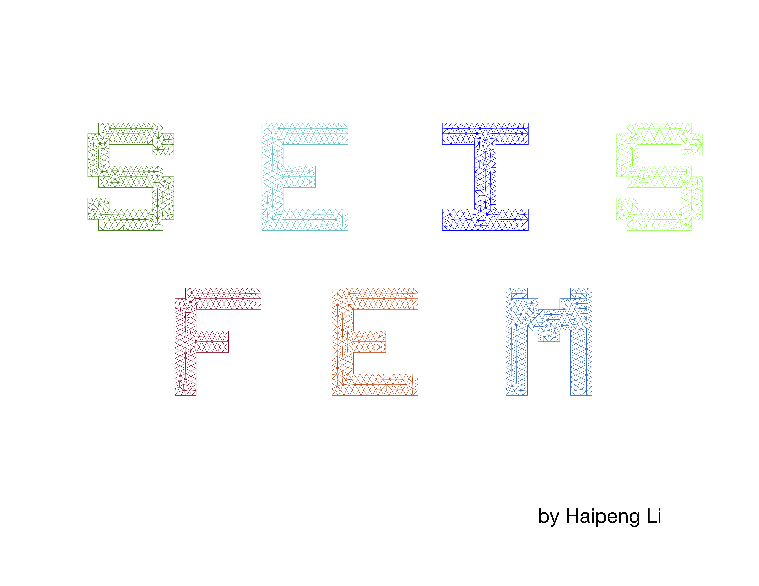

SEISFEM: 2D Finite Element Method Seismic

Wave Forward Modeling Code

By Haipeng Li

More detailed information will be added in the future…